Report for: | Cabinet
Date of Meeting: | 16th March 2023
Subject: | Cabinet and Member Engagement in the Commissioning and Procurement Programme
Key Decision: | Yes - the procurement programme will have an effect on all wards across the borough and therefore is deemed to fall within the parameters of a key decision
Responsible Officer: | Dawn Calvert - Director of Finance & Assurance
Portfolio Holder: | Councillor David Ashton - Portfolio Holder for Finance and Human Resources
Exempt: | No
Decision subject to Call-in: | Yes
Wards affected: | All
Enclosures: | Appendix 1 - Contract Procedure Rules Revision 2023  Appendix 2 - Procurement Programme (£100,000 and above) Pipeline April 2023-March 2024  Appendix 3 - Contracts awarded (£100,000 and above) in the period January 2022 to end of December 2022

Section 1 – Summary and Recommendations
This report sets out and seeks approval of the new approach to engagement and consultation with Cabinet in the council’s commissioning and procurement process. Secondly, it seeks amendments to the Contract Procedure Rules to incorporate as mandatory the proposed approach set out in this report along with a number of other revisions to the Contract Procedure Rules. Finally, this report sets out the procurement programme for all values over £100,000 for the period April 2023 to March 2024 and all contracts awarded over £100k in the period January 2022 to end of December 2022.

Recommendations:
Cabinet is requested to:

- Recommend to full Council to approve the amendments to the Contract Procedure Rules as set out in Appendix 1.

- Delegate the on-going updating of the annual procurement programme to the Director of Finance & Assurance in consultation with the Portfolio Holder for Finance and Human Resources and note that a procurement programme will be reported to cabinet annually.

- Note the procurement programme for all procurement with an aggregate value of over £100,000 for the period April 2023 to March 2024. Appendix 2

- Note all the contracts awarded over £100,000 during the period January 2022 to the end of December 2022. Appendix 3

- Note that the annual review of low value procurement activity up to £100,000 will be undertaken by the Head of Procurement in consultation with the Portfolio Holder for Finance and Human Resources.

Reason: (for recommendations)
To provide Cabinet with full oversight of the delivery of the procurement programme for the period January 2022 to end of December 2022,

Furthermore, to ensure that Cabinet has an early opportunity to see the planned procurement programme over £100,000 for the period April 2023 to March 2024 and to allow for early engagement of respective portfolio holders in each of the procurements under the programme over £500,000.

Finally, and to assure close communication and engagement with Cabinet and Portfolio Holders at all values of procurement, recommendation 5 is intended to offer assurance to Cabinet robust local authority governance and probity is in place in all procurement under £100,000.

Section 2 – Report

Introductory paragraph

The Council has an extensive annual procurement programme through which it contractually engages with third party organisations to provide works, goods, and services for the Council. Therefore, the Council has an important responsibility to ensure that the works, goods, and services are commissioned in line with the Council’s vision of delivering a well-run council that provides value for money and puts residents first and at the heart of everything we do.

Options considered

The two options considered for this report were:

- To continue to present Cabinet with individual reports over the year seeking approval to commence procurement for a specific contract without any engagement of portfolio holders in the planning and design of the commissioning and procurement and without cabinet having the opportunity to review and input into the tender documents as part of the cabinet reporting process.

OR

- To provide Cabinet with full and early details of the procurement programme for everything over £100,000 for the period April 2023 to March 2024, and to subsequently engage and consult in the planning and design pre procurement stage with portfolio holders and Cabinet on individual procurement projects over £500,000.

Option B was the preferred option to ensure Cabinet has further to their responsibilities valuable oversight and involvement in the delivery of the procurement programme and to allow for informed and strategic decision making at Cabinet and within and across directorates.

Background

During 2022-2023 the Council to date has spent c.£271m on procurement of its goods and services. These are payments made in this financial year to third party organisations with whom we have procured. Harrow Council, like most councils, is a commissioning organisation. Nearly all of the services that the Council delivers are through contracting with private and voluntary sector organisations to deliver on our behalf.

Therefore, the process and disciplines of strategic commissioning, procurement and contract management plays a pivotal role in ensuring the Council is buying the right things, at the right volumes, at the right price, in a strategically planned, well managed and timely manner, and that this is done in full compliance with The Public Contracts Regulations 2015, the Council’s Contract Procedure Rules and current best professional practice in procurement.

It is also important to note the global economic and political volatility, uncertainty, complexity, and ambiguity that will be with us for the foreseeable future. Which has a significant impact on Council commissioning and procurement.

The political, economic, social, legal, and environmental issues experienced in 2022 will continue to have an impact on public procurement in 2023. They are expected to include:

- High inflation
- Interest rate rises
- Energy price increases
- Cost-of-living pressures on consumers
- Supply chain prices rising due to Brexit, Russian invasion of Ukraine, and market volatility.
- The Procurement Bill expected to become law by the end of 2023 and replace the Public Contracts Regulations

Current situation

In the period January 2022 to end of December 2022 56 contracts over £100k were awarded and entered into by the Council as per the table below. The figure of £78,650,313 in the table below is the total contract value of the 56 contracts awarded. Contract payment will be across many future years.

Directorate | Contracts awarded January 2022 to December 2022 | Total Value of all contracts awarded
People | 7 | £8,337,813
Place | 32 | £61,368,450
Resources | 17 | £8,944,050
Total | 56 | £78,650,313
The detail behind each of the above awards is attached in Appendix 3.

The current governance process requires officers to seek approval from Cabinet to commence any procurement exercise over £500,000. The approval process however does not require comprehensive engagement and consultation with portfolio holders in the development of the scope of work, service or goods specifications, procurement strategy and other associated documents that together are referred to as the tender documents. The tender documents are developed by officers before and after approval to commence procurement has been granted by Cabinet. Engagement and communication about the commissioning and procurement is undertaken with portfolio holders but there is no approval by Cabinet of the tender documents.

Why a change is needed

The reporting of the procurement programme to Cabinet at the start of each calendar year will ensure that Cabinet is sighted on all procurement activity and that it is transparent. This approach will lead to commissioning and procurement that wholly engages portfolio holders and Cabinet in the procurement programme and ensures that they are involved, particularly in the design and planning of services, so that they can contribute to achieving the very best outcomes for our residents.

The proposed changes also reflect that:

- Cabinet oversees the council vision and strategic priorities and must be satisfied that the procurement and commercial arrangements for their delivery are robust.

- Cabinet makes key decisions on behalf of the Council in relation to the procurement process, particularly in regard to major projects, and therefore has an important role in maintaining oversight of the performance of key contracts, and agreeing corrective action where necessary

- When fully engaged with procurement processes and commercial matters, the quality of associated Cabinet decision-making is therefore better, and oversight and accountability are improved.

- Engagement of the Cabinet also leads to better project delivery and better outcomes for the local community which is important in the delivery of the vision of a well-run Council providing value for money and putting residents first.

The procurement programme for the period April 2023 to March 2024 is detailed in Appendix 2. Below is a summary.

Directorate | No of projects on the Procurement Programme Pipeline over £100,000  (April 2023-March 2024) | Budgeted Total Contract Value (includes initial term and any extension options)
People | 9 | £50,361,549
Place | 44 | £95,240,468
Resources | 21 | £109,468,286
Total | 74 | £255,070,303

Low value procurements below the reporting process

The Contract Procedure Rules require quotations for all procurement below £100,000. This process also seeks to engage and contract with local SME/VCS providers of services by encouraging officers to seek a minimum of 1 quotation from a local provider. The procurement of works, goods and services below £100,000 are not subject to the Public Contracts Regulations 2015 and there is a high degree of flexibility in the way we undertake the engagement of suppliers at these low values.

The procurement team does not support this process, and it is incumbent on the procuring officer to comply with the Contract Procedure Rules. However, there are controls within the Council’s main accounting system Microsoft D365 that require the quotations that have been received to be attached to the requisition. This comes through to the procurement team by a system called ‘Describe what you need’ for review and approval.

The procurement team as per recommendation number 5 will undertake an annual check on all expenditure that fall under the £100,00 threshold in consultation with the Portfolio Holder for Finance and Human Resources to ensure compliance and value for money.

What will the Change look like?

The required change is simple but significant and is that closer consultation and engagement of Portfolio Holders in the commissioning and procurement process that are proposed in this report, particularly in the areas of design and planning of services, will enhance the opportunity to deliver better outcomes across all procurement and commercial activity.

The approval to commence a procurement process from Cabinet for each procurement project and oversight of the associated tender documents will create a holistic and effective partnership of delivering the procurement programme and will support the Council vision of putting residents first and demonstrating value for money.

How will this work ‘on the ground?’

At the point of project initiation officers will begin their consultation, communication, and engagement with the portfolio holder on the work being undertaken to design the key tender documents. They include the specification/scope of works, the selection and evaluation questions that will be asked of tendering organisations and the respective score weighting attributed to the questions, the procurement options and the preferred option, the financial issues such as the budget and how the markets will be asked to provide their financial bids. The service area portfolio holder and any other portfolio holder that is identified as a stakeholder in the procurement will be engaged in the pre-procurement process where their influence will be significant and high.

Engagement and consultation with portfolio holders and cabinet may include:

- preliminary market consultation
- the specification/scope of works,
- the questions that bidders will be asked, and the respective score weighting attributed to the questions
- the price/quality spilt / the evaluation criteria
- the procurement options and the preferred option,
- the financial issues such as the budget and how the markets will be asked to provide their financial bids.

The table below shows the stages in the procurement process where portfolio and Cabinet interest, engagement and influence will be at its highest.

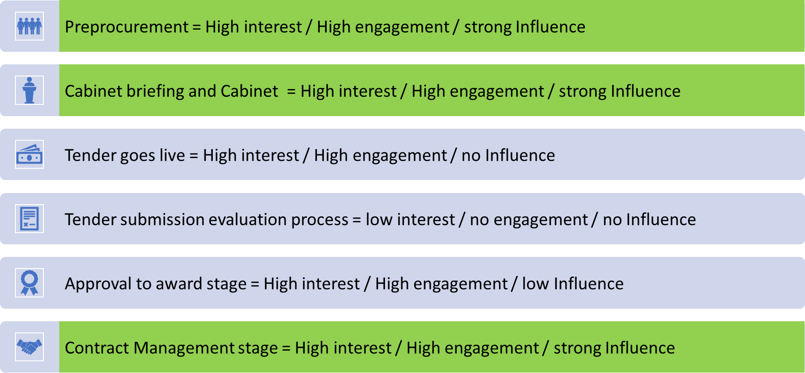

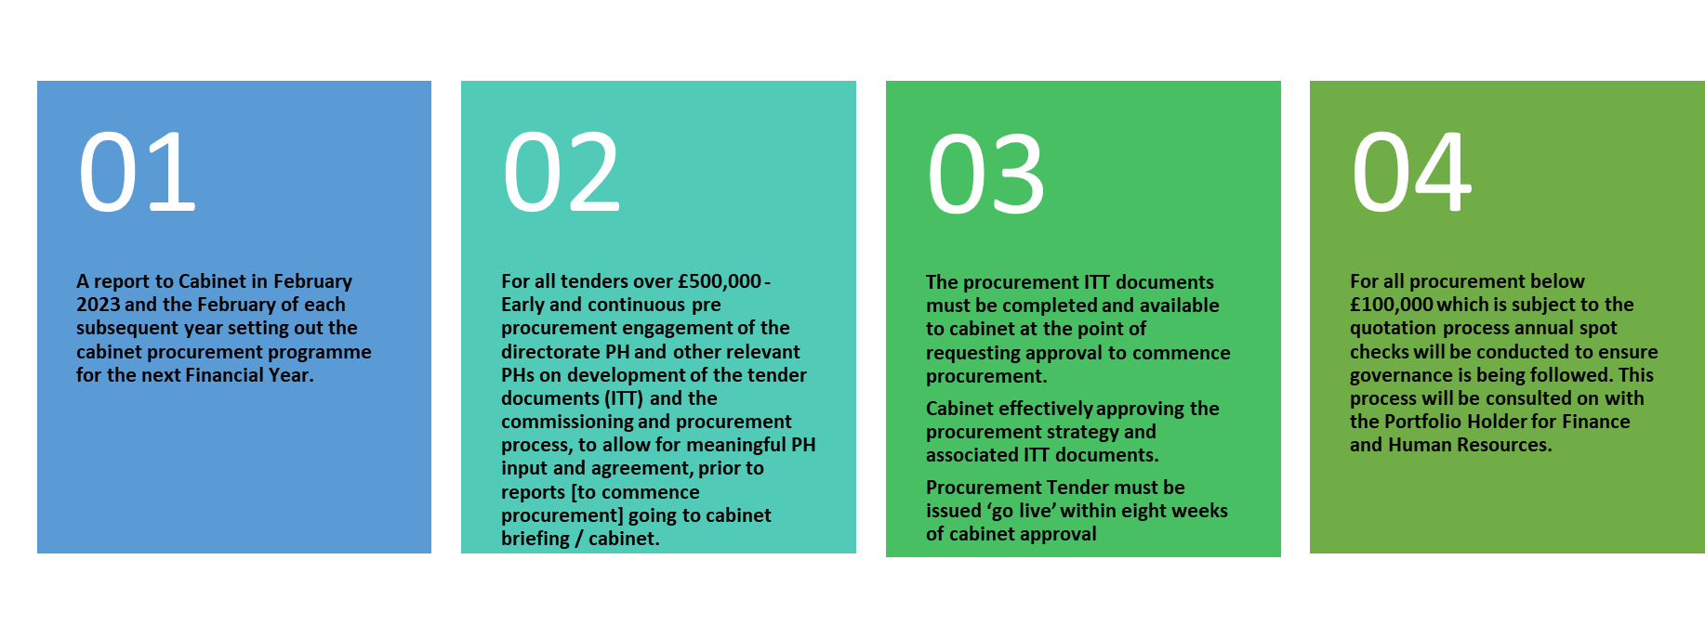
The diagram below is a summary of the proposed changes to deliver Cabinet and Portfolio Holder engagement in procurement.

Implications of the Recommendation

There are no implications associated with the recommendations from a resources or financial perspective. The change to the new approach of engaging and consulting portfolio holders and Cabinet on the procurement programme will primarily require a change to working practice. Officers involved in the commissioning and procurement processes must now ensure portfolio holder engagement in the development of the tender documents and then final inclusion of the tender documents as a background document for approval with the Cabinet report seeking approval to commence procurement. The tender documents may have to be considered as Part 2 papers in the Cabinet report as they will contain financial information that should only be visible to the market when the procurement process goes live.

Given the significant involvement of portfolio holders in the procurement process, a further key implication will be to ensure portfolio holders are trained in procurement and the training incorporates confidentiality, non-disclosure and declaration of interest requirements as these are additional risks of the new arrangements proposed in this report.

Risk Management Implications
Risks included on corporate or directorate risk register? No

Separate risk register in place? No: A risk register will be created for each procurement under the procurement programme

The relevant risks contained in the register are attached/summarised below. N/A

The following key risks should be considered when agreeing the recommendations in this report:

Risk Description | Mitigations | RAG Status
The Council fails to take appropriate measures to effectively prevent, identify and remedy any conflicts of interest arising with members in the conduct of procurement procedures, including conflicts of interest between duties and responsibilities of Portfolio Holders and members at the strategic level and at operational levels of procurement | - We will require Cabinet members to sign a declaration of confidentiality and non-disclosure on an annual basis.  - Additionally, we will require a further individual procurement-specific declaration of any conflict of interest from Portfolio Holder or members relating to each procurement Portfolio Holders or Members are involved in or contributing to at the operational level  - Training given to Portfolio Holders and members and will specifically cover the area of Conflict of Interest and how to comply with The Public Contracts Regulations 2015 (PCR) and the Council’s Contract Procedure Rules and Financial Regulations | Amber
Portfolio Holders could, based on their relative lack of experience and expertise in procurement, and also on their knowledge of the tender documents, give advance notice or otherwise disclose tender requirements to tenderers, in such a way as to give these tenderers an unfair advantage over other tenderers | - We will require Cabinet members to sign a declaration of confidentiality and non-disclosure on an annual basis.  - Where necessary, the ITT will be a Part 2 document of the Cabinet report thereby making it confidential and not visible to tenders until the tender goes live | Amber
Officers not adopting the new approach leading to non-compliance with the Contract Procedure Rules | - Recommendation 1 is seeking approval to amend the Contract Procedure Rules to ensure and embed the new approach so that it is seen as mandatory and not desirable  - Over 250 officers from across the Council have been trained between November 2022 and the end of January 2023 on the procurement rules including the new arrangement on member involvement.  - Procurement boards in each directorate will ensure compliance with the new requirements.  - Annual spot review of compliance. | Green
Delays in tendering timetables. | - The visibility of the procurement programme to Cabinet and the new approach adopted should not create any delays as there is no change to the process other than having the tender documents ready for Cabinet to approve. | Green
Portfolio Holders do not have the technical skills and expertise in the commissioning and procurement process to engage meaningfully at the operational level. | - Portfolio holders have been engaged and consulted on the development of tender documents and have demonstrated how useful their input is to the process.  - The CPRs and a procurement FAQ document has been circulated to Cabinet members to support their development and understanding of the procurement / tendering process.  - Training in procurement will be given to members in the spring of 2023 enhancing knowledge of the commissioning and procurement process and to develop their expertise | Amber
Involvement in the procurement programme is too resource intensive for portfolio holders. | - Cabinet have agreed to undertake pilots where each directorate will identify tenders to pilot, and the pilot process will be used to learn lesson and modify the process as necessary | Amber
Where approval is being sought from cabinet for a programme of procurement, delegated authority is not given to the Corporate Director in consultation with the Director of Finance and Assurance (S151 Officer) and also the Portfolio Holder responsible for the programme to commence each procurement and to award all contracts under the programme | - The principle of this delegation is stated throughout the Council’s Contract Procedure Rules (and specifically at Section 3.5) and is required practice and is utilized to ensure the lean and efficient delivery of procurement projects and programmes | Green
Cabinet reports seeking approval for a procurement for the acquisition of works, goods or services are not accompanied by the tender documents and a recommendation seeking approval of the tender documents | - It will be a requirement of the Contract Procedure Rules to have the relevant tender documents appended to the cabinet report as a background paper (see also Recommendation 1 above) | Green
Procurement commences later than the 8-week period with no prior approval for an extension of the 8-week period | - The requirement for this approval will be in the Contract Procedure Rules (see Recommendation 1 above)  - Where delays are experienced, those officers given delegated authority to make awards must be kept informed further to Contract Procedure Rules | Green
All commencement and award approvals do not follow the procurement gateway process. | - All commencement and award approval are strictly governed by the Contract Procedure Rules and the Financial Regulations which outline the procurement reporting process and the scheme of delegation, and any non-compliance is a fundamental breach of these rules | Green
The procurement team fail to undertake an annual check on all expenditure falling under the £100,000 limit to ensure compliance and value for money have been achieved. | - The annual check will become part of our business-as-usual approach to procurement and the requirement to undertake the check will be included in our annual service plan.  - As the check is included in our service plan the annual check will also be cascaded down to staff work plans | Green

Procurement Implications
There are no direct or immediate procurement implications insofar as they relate to the Public Contracts Regulations 2015 arising from the recommendations set out at the beginning of this report. However, all tendering projects and procurement awards resulting from the procurement programme included in this report under Appendix 1 will be undertaken only after the requisite internal governance approvals have been received. All procurement activity must be compliant with the Public Contracts Regulations 2015, the Council’s Contract Procedure Rules and Financial Regulations.
The impact of the recommendations will be a change in working practices for those involved in the delivery of the procurement programme. Officers engaged in the development of the component parts that together make up the tender documents will need to ensure that engagement of portfolio holders is at its highest in the design and development pre-procurement phase.
All communication should be through approved formal channels set up for the procurement.
Secondly, all reports that Cabinet need to approve in the procurement programme will have the procurement implications set out for the specific tendering project as well as a new standard recommendation as per the guidance as follows:
Officers when submitting cabinet reports are requested to use the following form of words:
Cabinet is recommended to:
- approve the commencement of a procurement process for the provision of X. The term of any future contract award following a competitive and compliant procurement exercise will be Y years plus an additional Z years extension option.
- approve the tender documents.
- delegate authority to the Corporate Director for X, in consultation with the Portfolio Holder responsible for the Service, to make any changes required to the tender documents following approval.
- delegate authority to the Corporate Director for X in consultation with the Director of Finance, the Portfolio Holder for the Service and the Portfolio Holder for Finance and Human Resources to award the contract.

Legal Implications
All council procurement must be carried out fairly and transparently and where relevant in compliance with The Public Contracts Regulations 2015 (PCR) and the council’s Contract Procedure Rules and Financial Regulations.

Members can engage with and influence the procurement process but, like officers, must comply with the procurement principles set out in the PCR. These are to treat economic operators equally and without discrimination and to act in a transparent and proportionate manner. They must not seek to design the procurement with the intention of unduly favouring or disadvantaging certain economic operators.

Confidentiality must be appropriately maintained at all times

The council must take appropriate measures to effectively prevent, identify and remedy conflicts of interest arising in the conduct of procurement procedures so as to avoid any distortion of competition and to ensure equal treatment of all economic operators. For these purposes, the concept of conflicts of interest shall at least cover any situation where relevant staff members or councillors have, directly or indirectly, a financial, economic or other personal interest which might be perceived to compromise their impartiality and independence in the context of the procurement procedure.

Contracts must be awarded to the most economically advantageous tender as determined by applying the published selection and evaluation criteria to the tender fairly, transparently, and in a non-discriminatory way.

Selection criteria may relate to:

(a) suitability to pursue a professional activity
(b) economic and financial standing
(c) technical and professional ability

Contract award criteria must be linked to the subject-matter of the contract.

The council must specify, in the tender documents, the relative weighting which it gives to each of the criteria chosen to determine the most economically advantageous tender, except where this is identified on the basis of price alone.

Financial Implications
There are no financial implications arising from the recommendations set out at the beginning of this report. The procurement governance process requires, as mandatory, finance to approve availability of budgets prior to a tender process proceeding or an award of contract being made.

The Financial Regulations currently delegate the power to award contracts as set out below:

Delegation | Award of Contract (Total Value over life of Contract) | Counter signature (*)
Cabinet | Over £500,000
Head of Paid Service  OR  Chief Financial Officer | £250,000 to £499,999 | Portfolio Holder for Finance and Human Resources
Corporate Director / Director of Finance | £100,000 to £249,999
Director (D grades) | £50,000 to £99,999
‘M’ grades | £25,000 to £49,999
‘G9 to G11’ grades | £0 to £24,999

Financial due diligence is also undertaken on all companies we intend to contract with to ensure they have the financial strength to deliver the contract.

Equalities implications / Public Sector Equality Duty
An Equalities Impact Assessment is not required for the recommendations set out in this report. An equalities impact assessment will be undertaken for procurements that are part of the programme of procurement detailed in this report.

Section 3 - Statutory Officer Clearance
Statutory Officer: Dawn Calvert
Signed by the Chief Financial Officer
Date: 23 February 2023
Statutory Officer: Stephen Dorrian
Signed on behalf of the Monitoring Officer
Date: 15 February 2023
Chief Officer: Dawn Calvert
Signed on behalf of the Chief Executive
Date: 23 February 2023
Head of Procurement: Nimesh Mehta
Signed by the Head of Procurement
Date: 23 February 2023
Head of Internal Audit: Neale Burns
Signed on behalf of the Head of Internal Audit
Date: 1 March 2023

Mandatory Checks

Ward Councillors notified: NO

EqIA carried out: NO
An Equalities Impact Assessment is not required for the recommendations set out in this report. An equalities impact assessment will be required for procurements that are in scope of the recommendations of this report.

EqIA cleared by: N/A

Section 4 - Contact Details and Background Papers
Contact: Nimesh Mehta, Head of Procurement, Tel. 07949 054 739, Email: Nimesh.Mehta@harrow.gov.uk
Call-in waived by the Chair of Overview and Scrutiny Committee - NO

